Geoff Bohling
05 September 2005

Introduction to Geostatistical Reservoir Modeling Exercise

This exercise is intended to familiarize you with the basic steps in a geostatistical analysis of reservoir properties. We provide three data files, one for each of three zones (A, B, and C) in the Big Bean Field. Measured values of zone thickness and porosity are available from 85 wells in an area that is 20 km in the east-west (X, positive east) direction and 16 km in the north-south (Y, positive north). Measured values of permeability are available for 42 of the 85 wells in zones A and B and 56 of the 85 wells in zone C. We will demonstrate the analysis steps for zone A using WinGslib. You should follow through with the analyses for zones B and C. Be sure to print copies of relevant output so you can document your final report of your analyses.

Data File Layout

The data for each zone are contained in a GSLIB-style data file. The opening lines of the data file for zone A, named ZoneA.dat, are as follows:

Zone A Data, Big Bean Field
8
X m meters east of origin
Y m meters north of origin
Thk m zone thickness in meters
Por % porosity in percent
Perm md permeability in millidarcies
LogPerm - base 10 log of permeability
LogPermPrd - LogPerm predicted by regression against Por
LogPermRsd - Residual from LogPerm-Por regression
12100 8300 37.1531 14.6515 2.8547 0.4556 0.1357 0.3198
5300 8700 31.4993 14.5093 -999.9999 -999.9999 -999.9999 -999.9999
3500 13900 36.9185 14.0639 -999.9999 -999.9999 -999.9999 -999.9999
5100 1900 24.0156 15.1084 1.1407 0.0572 0.2268 -0.1696
9900 13700 35.0411 13.919 -999.9999 -999.9999 -999.9999 -999.9999

The missing values for permeability (and related values) are indicated by –999.9999 and will be excluded from analysis by specifying appropriate trimming limits. The variable LogPerm is simply the base 10 logarithm of the measured permeability values, as indicated. The variable LogPermPrd contains log permeabilty values predicted by a regression of LogPerm versus porosity for the 42 wells with permeability measurements. The last column, LogPermRsd, contains the residuals from that regression line (LogPerm – LogPermPrd). These values are provided because we will krige the LogPerm values using Por as a covariate and for that analysis we need to compute the variogram of LogPermRsd, rather than LogPerm itself. The data files for the other two zones (ZoneB.dat and ZoneC.dat) have identical formats.

Setting Up the Project in WinGslib

Copy the three data files to a folder on your hard drive. For this demonstration, we will use the folder C:\GCB\BeanField\demo, but you may use any folder you choose. Then start WinGslib and select New project from the File menu:

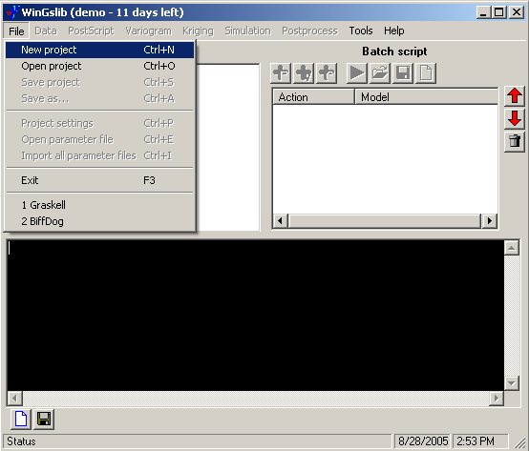

In the Data files text box on the resulting dialog box, type in the name of the folder containing your data files or click on the folder button to the right to browse to that folder. The program will automatically enter the same folder name in the Output files and Parameter files text boxes, but you may change these to point to other folders if you wish. For this demonstration we will keep output and parameter files in the same folder. Also, enter a meaningful name for your project, and then click OK:

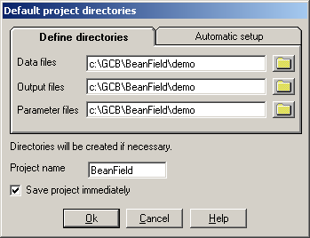

Assuming you have Save project immediately checked, a subsequent dialog box for saving the project file, with the name given above, will appear. Click OK on that dialog box as well. Next, go to the instruction file, ExploratoryAnalysis.doc.

